**Lab6**

**Configure EBS Volumes, Snapshot and creating AMI**

**PLEASE READ THE BELOW NOTE BEFORE PRACTICE THIS LAB**

**Below lab is COST BASED lab, we need to pay some amount to amazon for resizing the partition and resized portioned snapshot. If you are interested to do the lab please resize the volume as 1 GB and try this scenario. The below mentioned scenario is partially success because we have created the windows image and use the AMI for with an instance. But we are unable to launch the instance in this case. Sir will teach creating AMI session by using the instance image in this class later with Auto scaling concept.**

**Click “EC2”.**

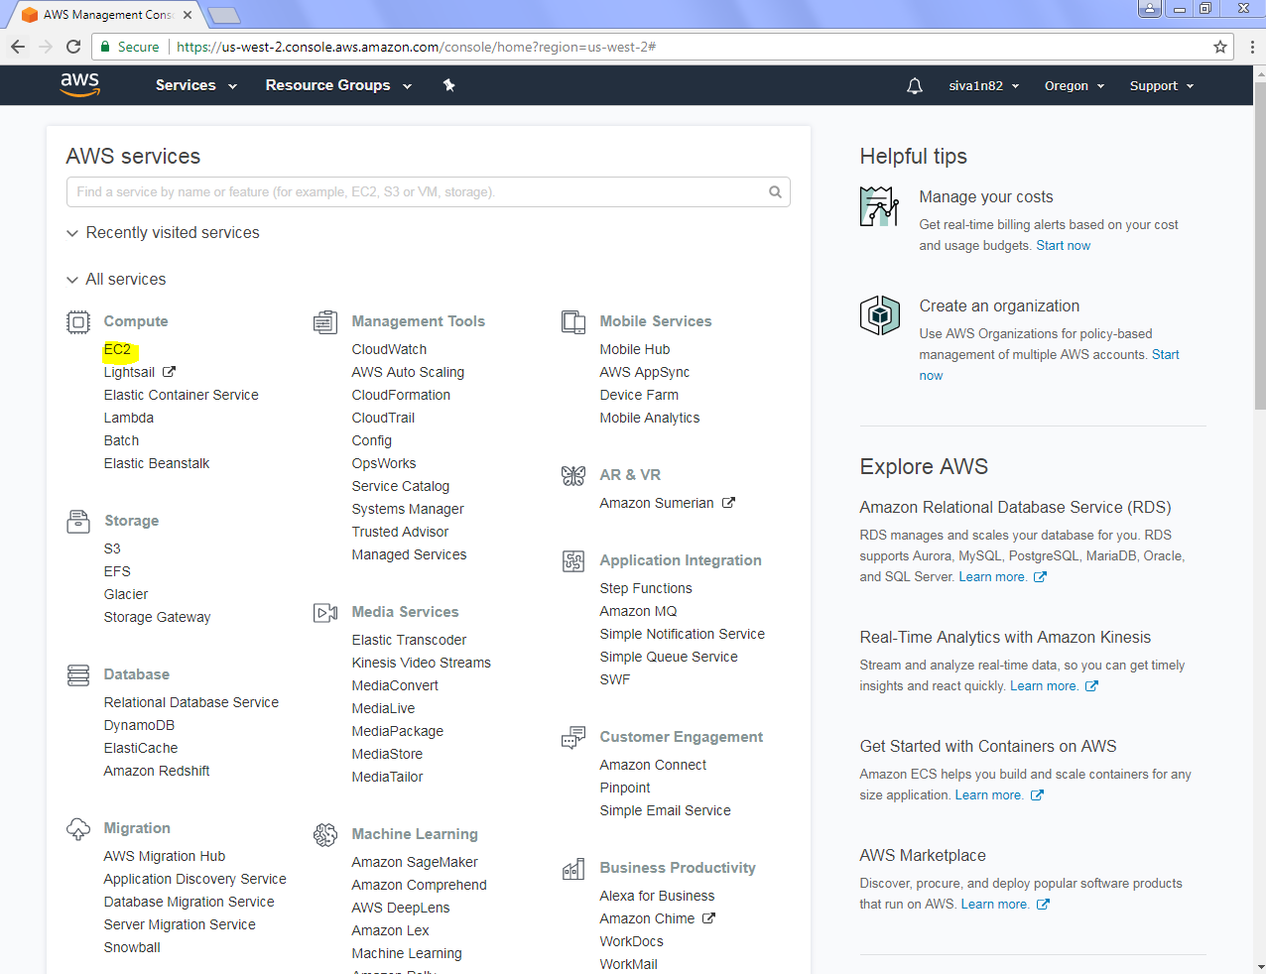

Click “Launch Instance”.

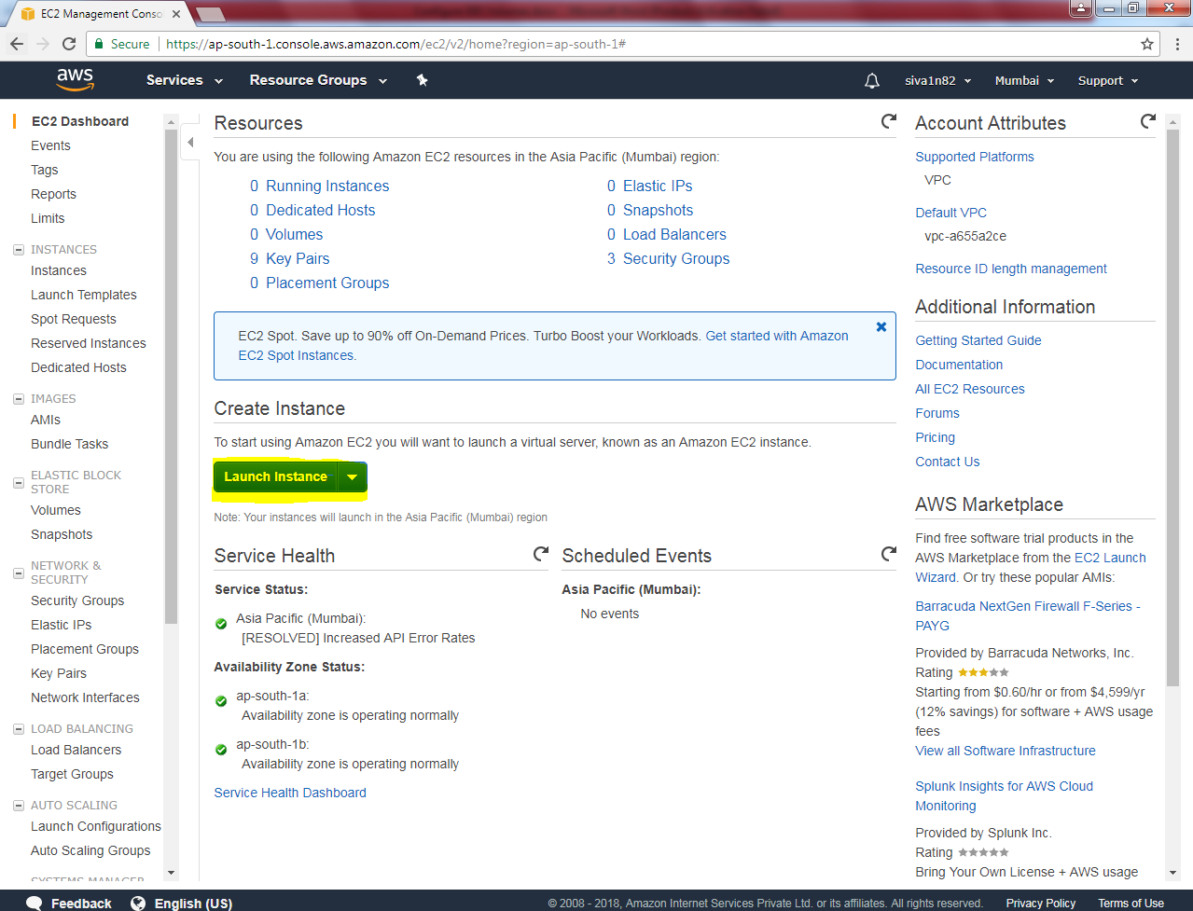

Select “Windows Server 2016 Base”.

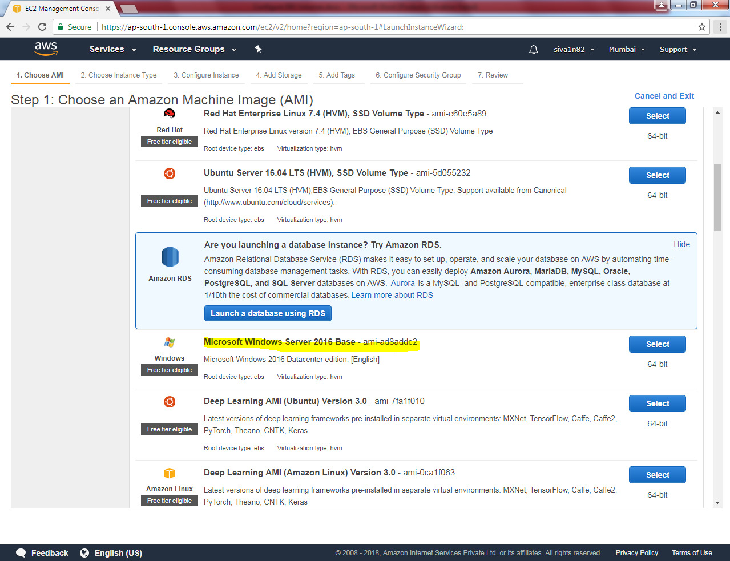

Select “t2.micro”.

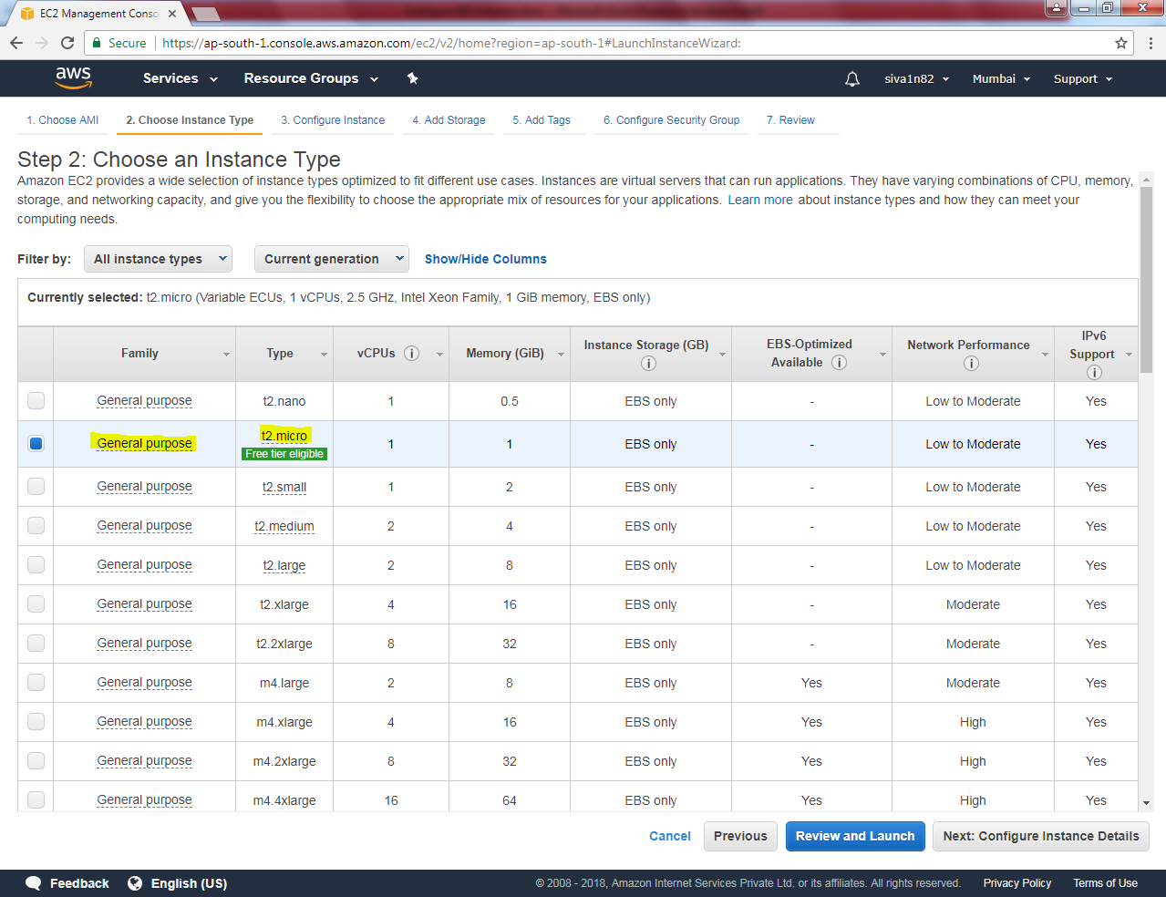

Click “Next”.

Leave default settings and click “Next”.

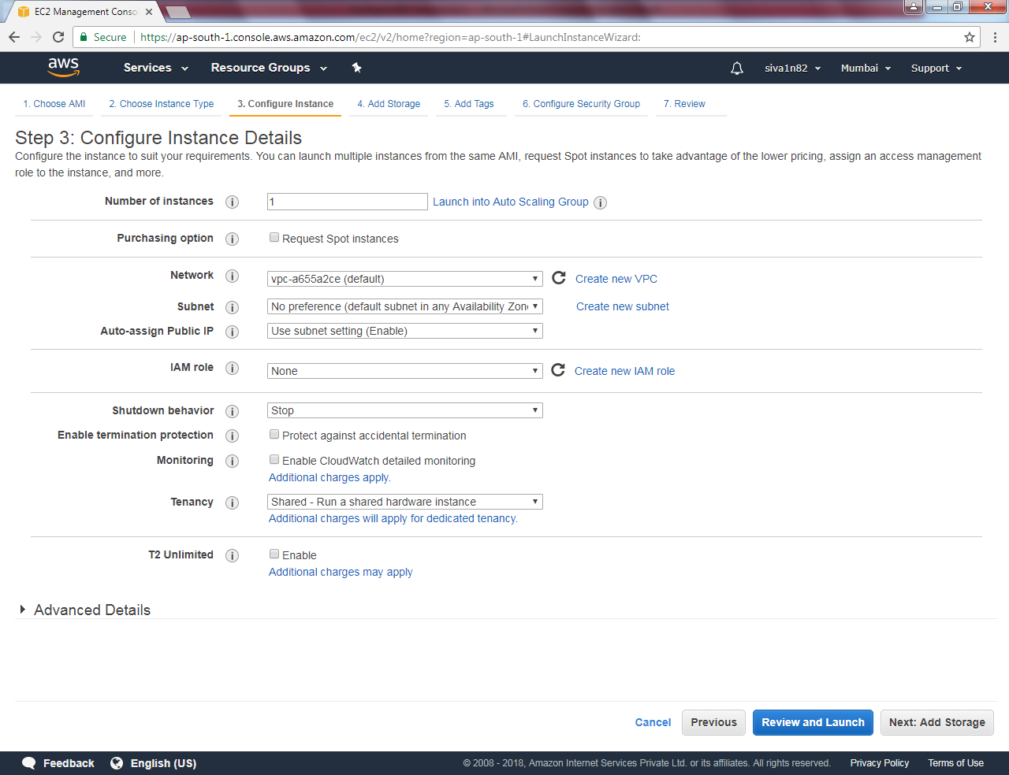

Leave default settings and click “Next”.

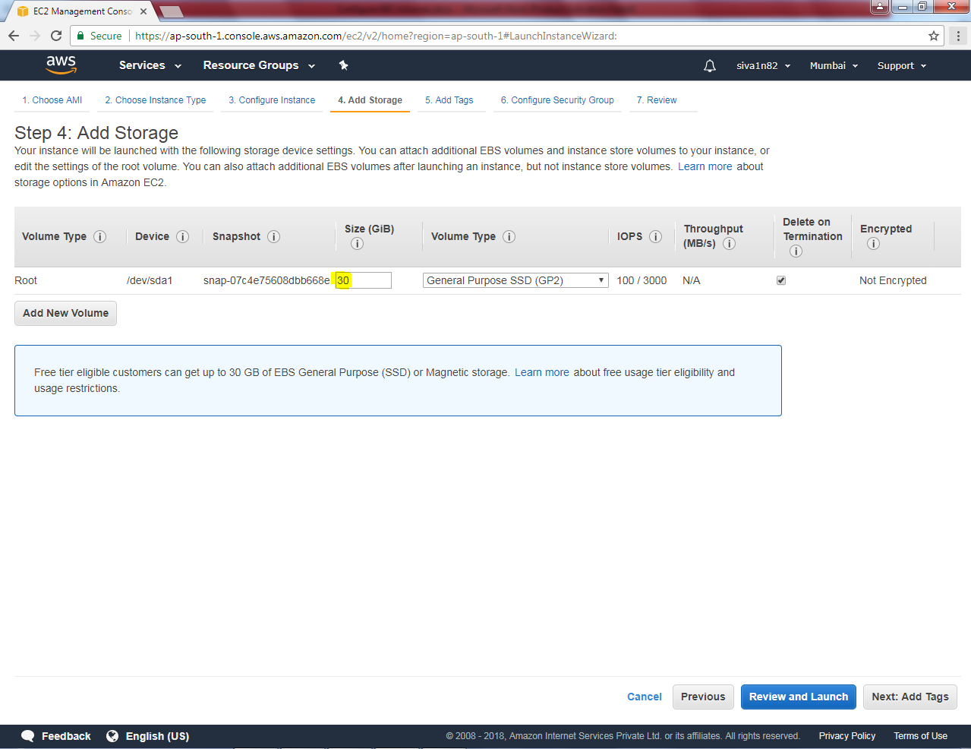

Key as “Name” and Value as “Windows 2016 EBS”.

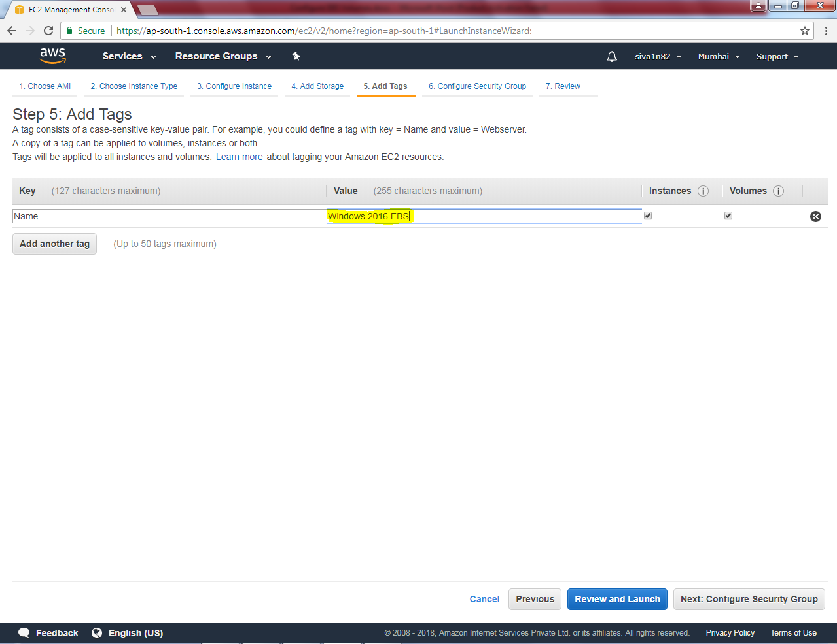

Click “Next”.

Create a new security called “Mumbai Sec Group”.

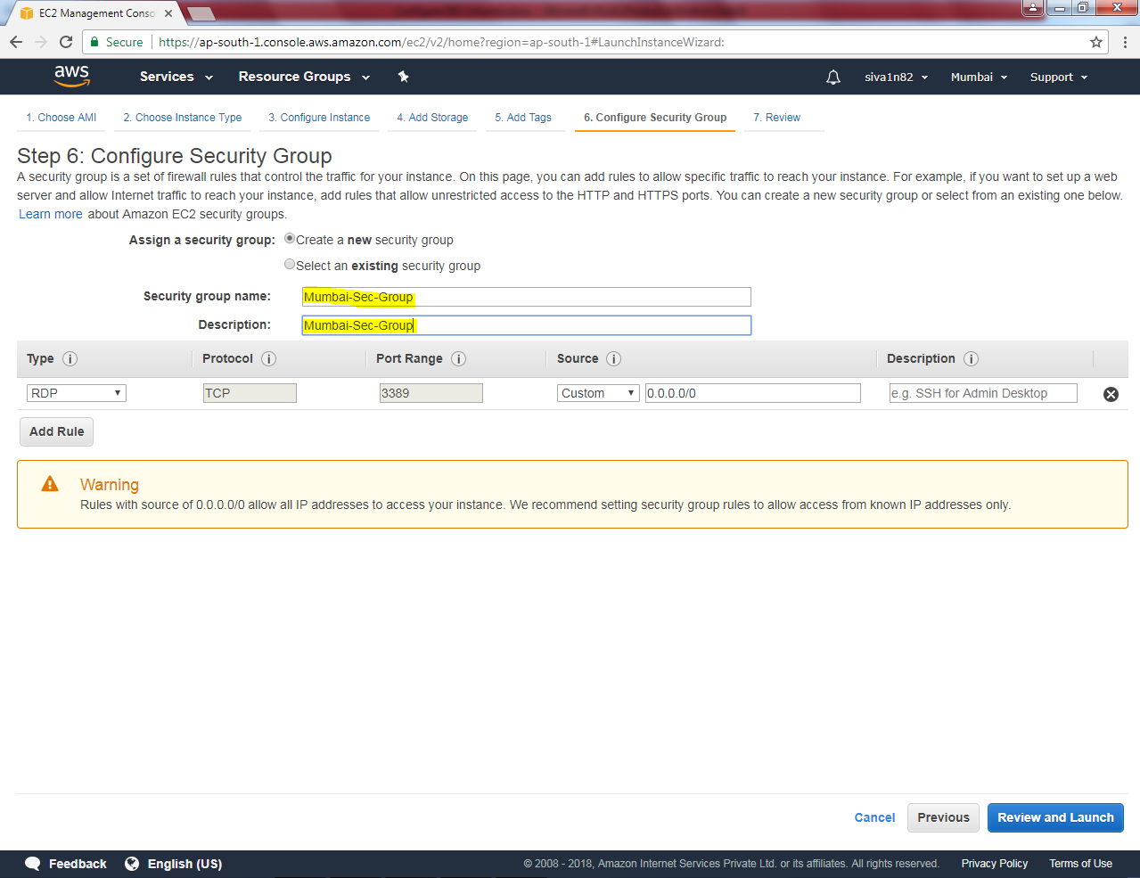

Click “Review and Launch”.

Leave default settings and click “Launch”.

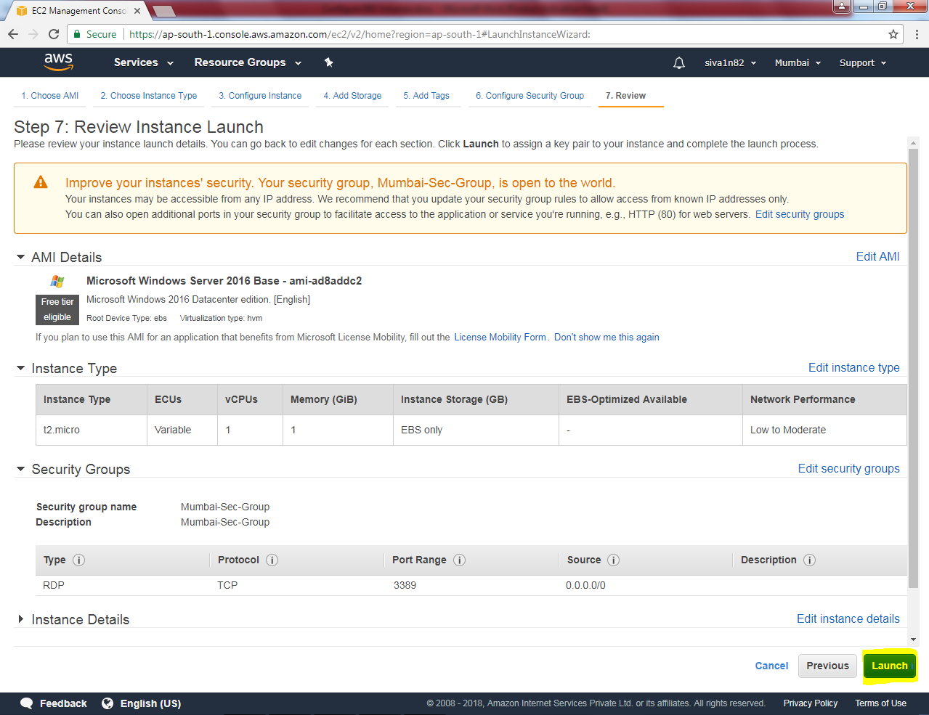

If you have existing key choose an existing key pair and select the Key pair. Other wise you need to create an new key pair. Click “ I acknowledge”.

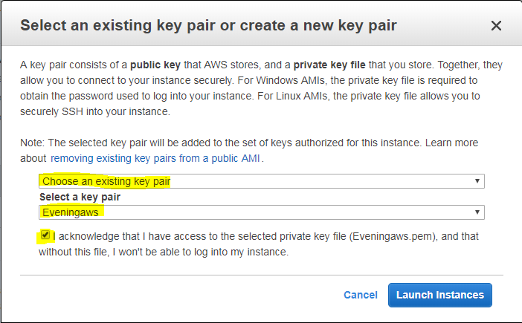

Click “launch Instance”.

Click the highlighted area to view the instance.

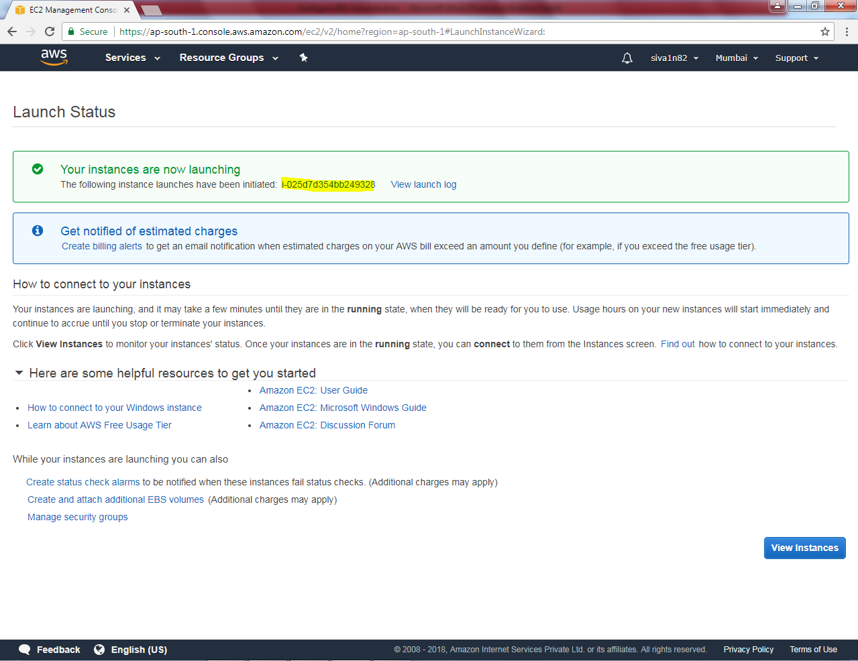

Server is getting ready, wait up to 2/2 status checks.

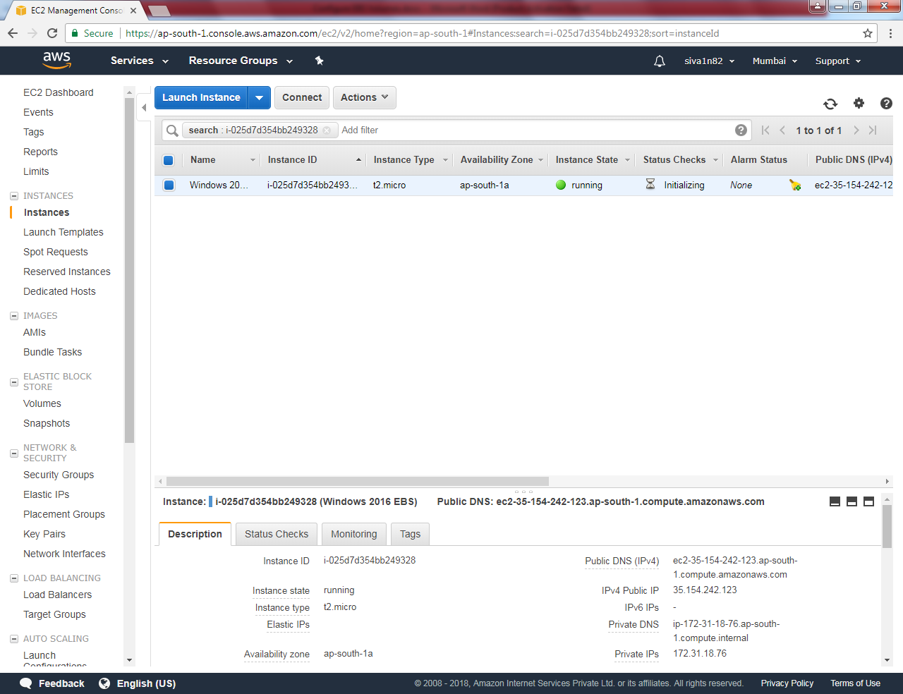

Click “Actions”

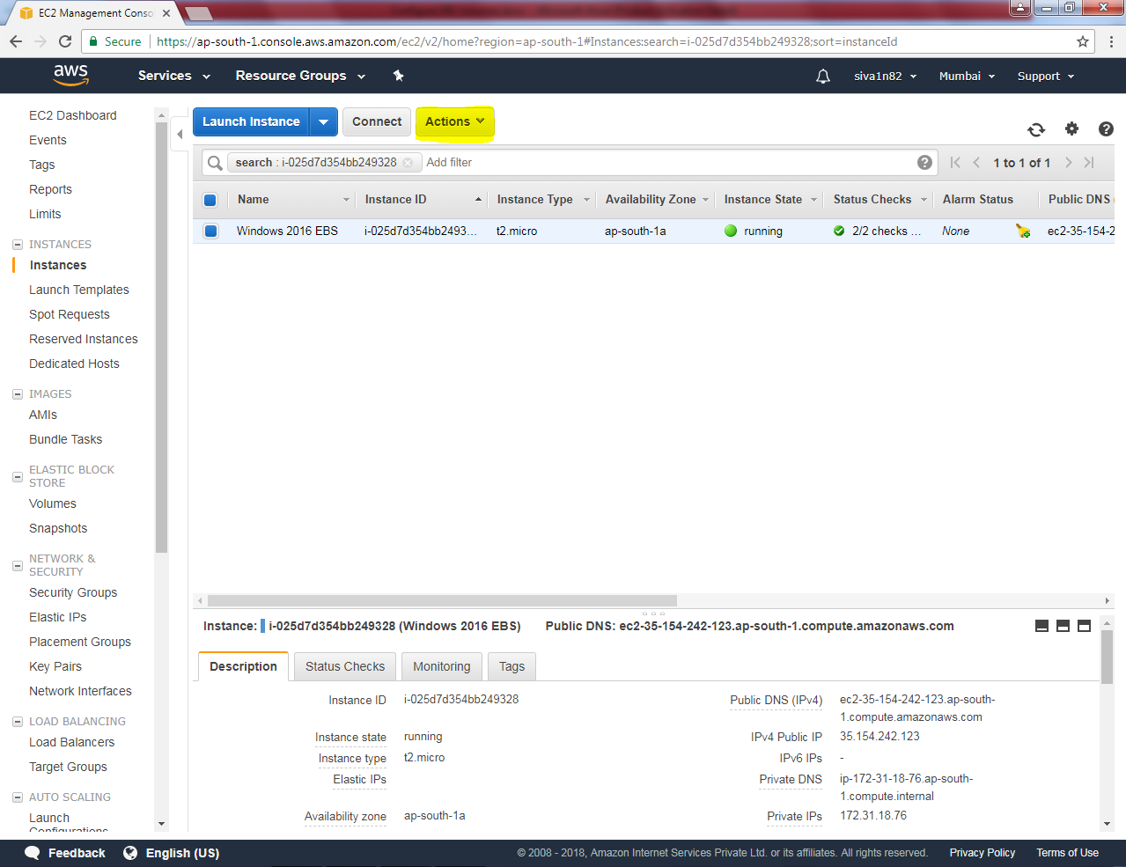

Click “Get Password”.

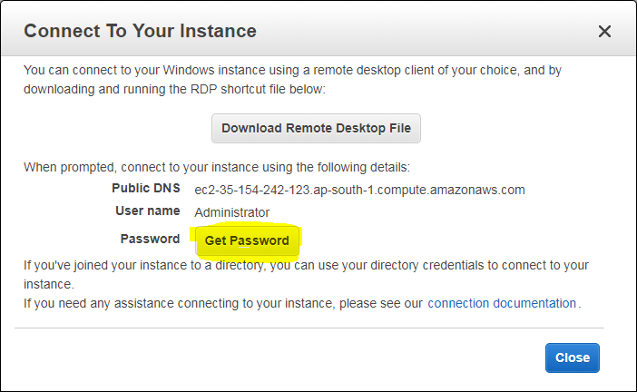

Click “Choose File”.

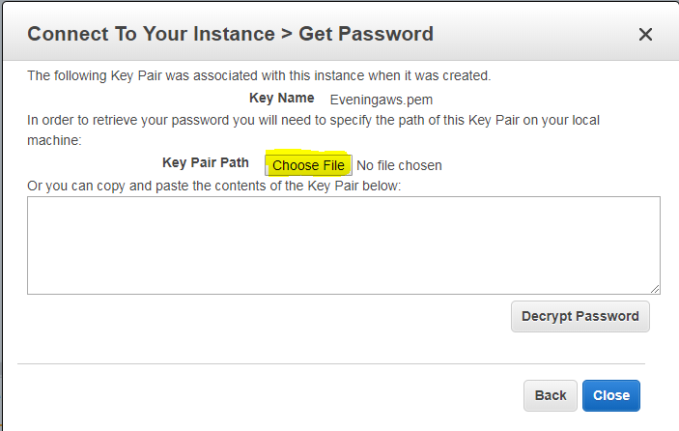

Locate the “Eveningaws.pem” file.

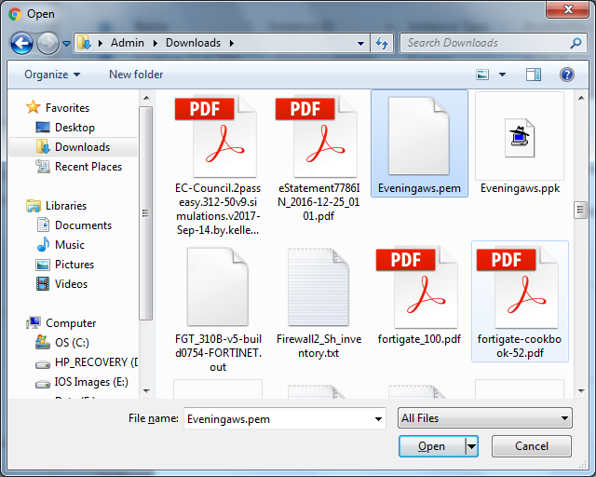

Click “Open”.

Click “Decrypt Password”.

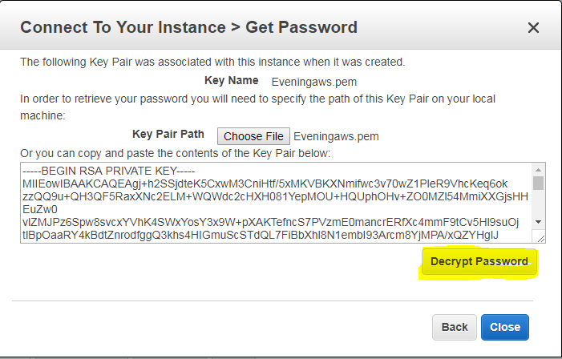

You have got the password successfully.

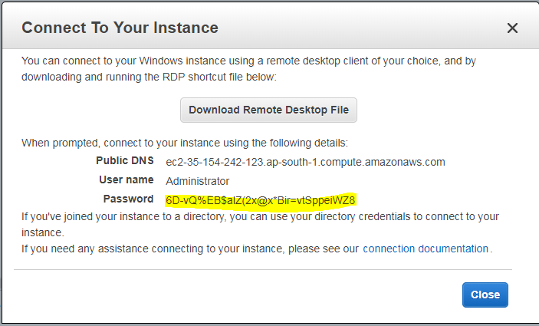

Type mstsc in run box, then type the Ip address of the server.

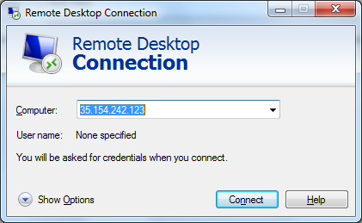

Type the login credentials provided by awS.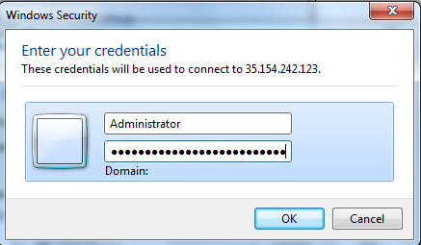

Click “Yes”.

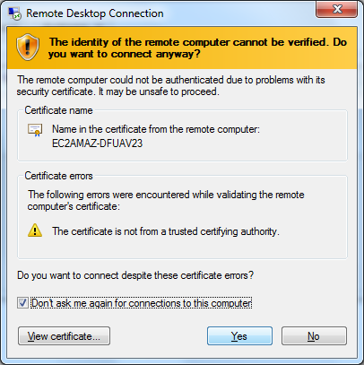

We have connected the server successfully.

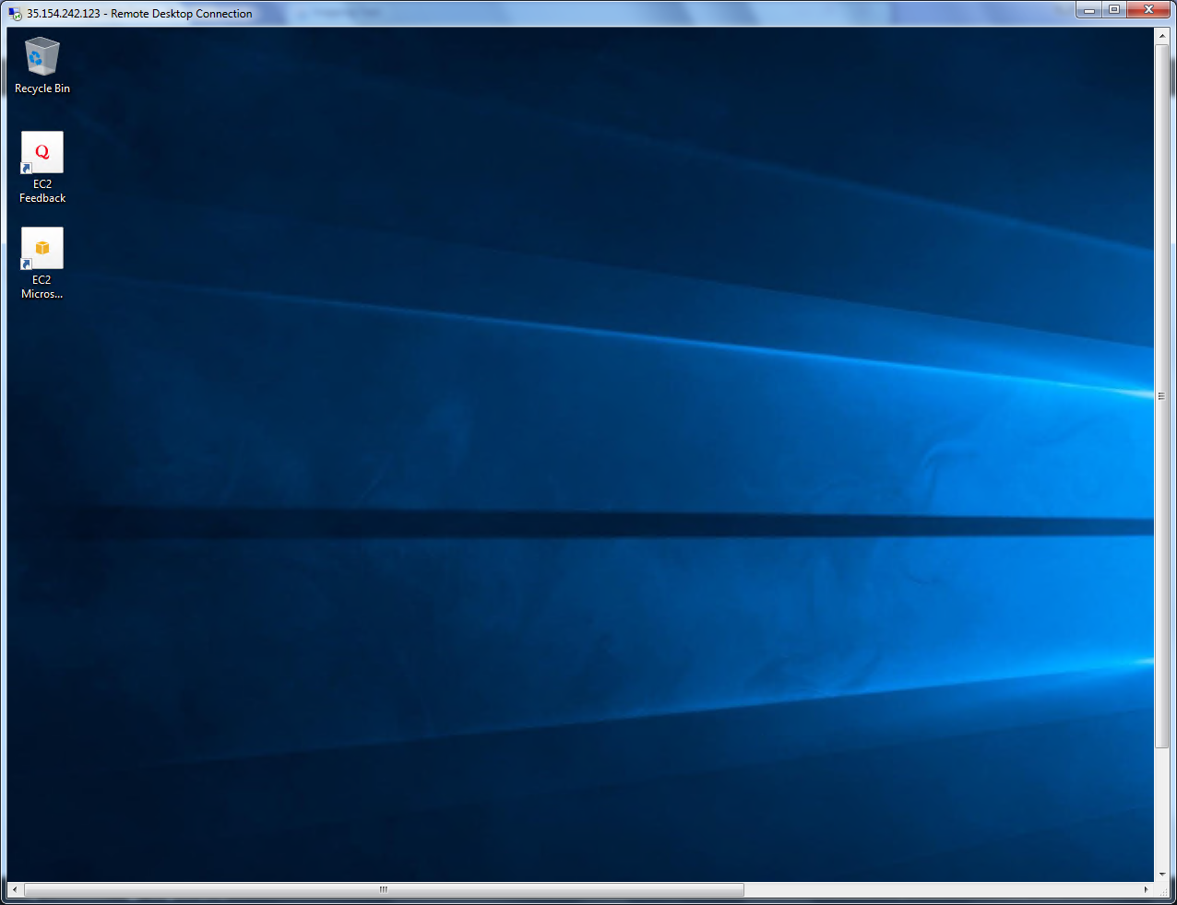

Now we need the modify the volume in AWS console.

Click “Volume”.

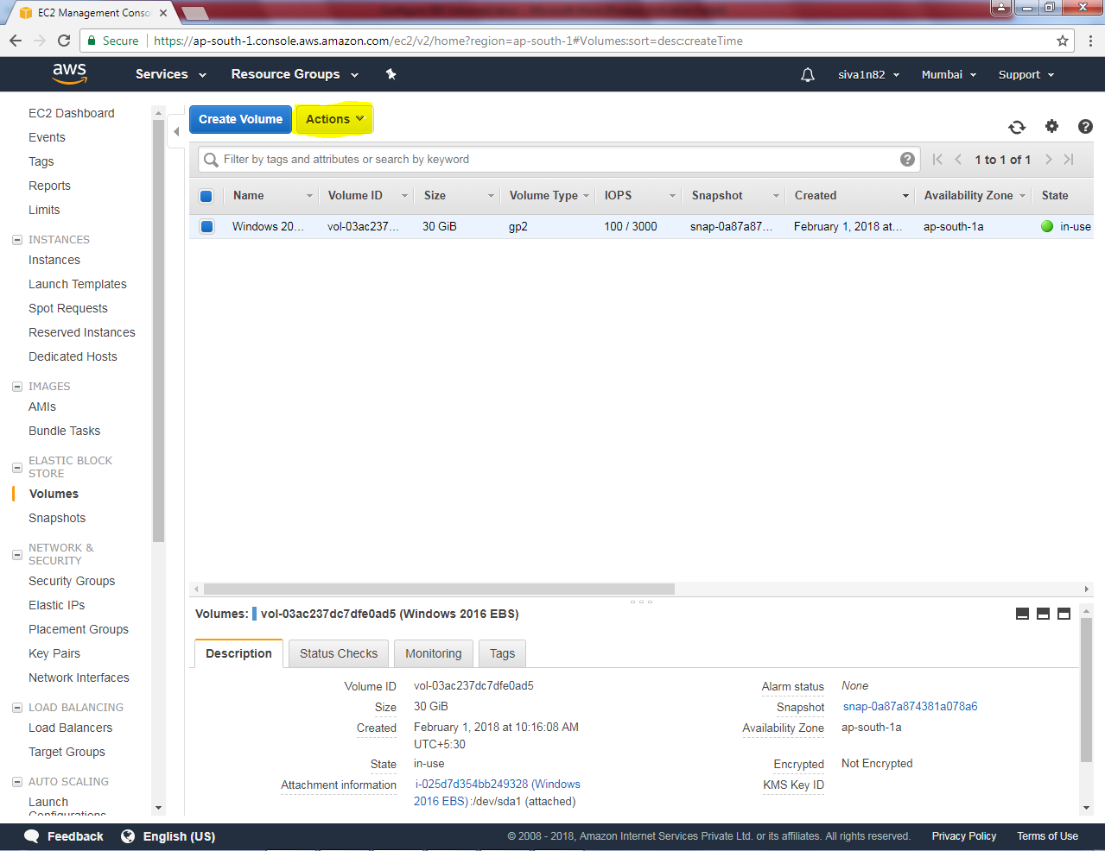

Click “Modify volume”.

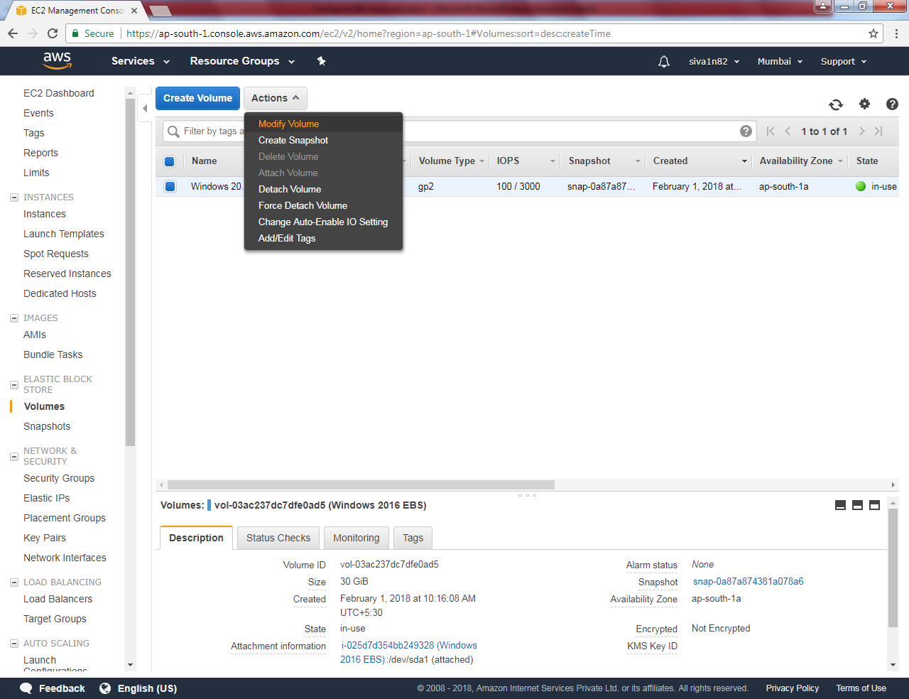

Type the size is 35GiB**. (If you want to make it as 31GiB you can do the same).**

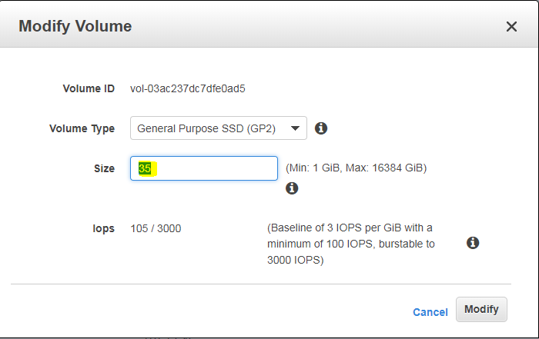

Click “Modify”.

Click “Yes”.

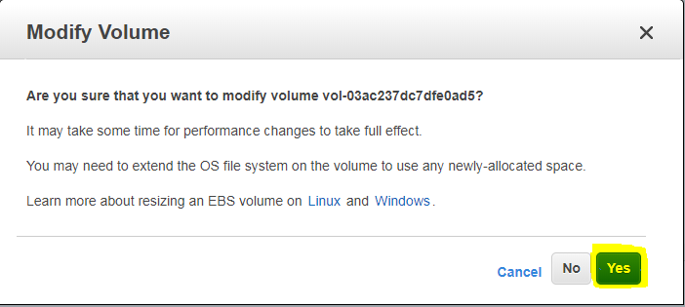

We have got information that Modify volume request succeded.

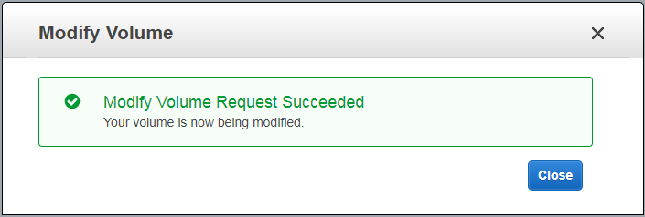

Right click start menu to get “Disk management”.

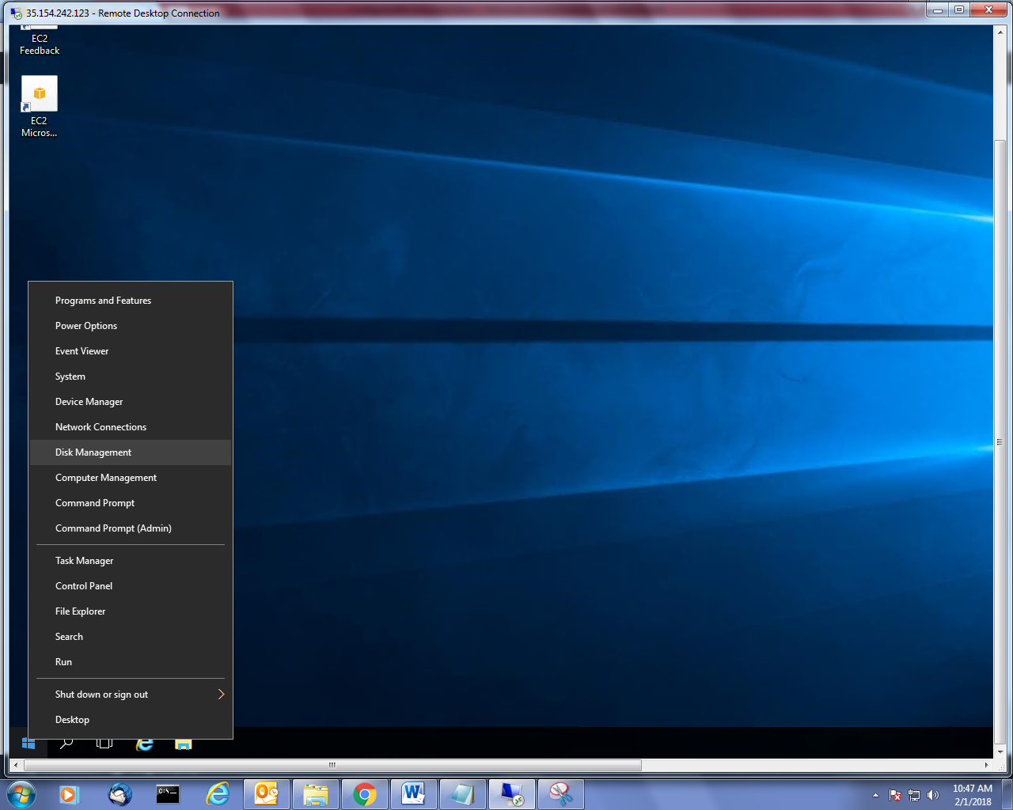

Open the disk management, modified partition will not shown by default. You need to press “F5”. Now you can able to see “5.0” GB in unallocated partition.

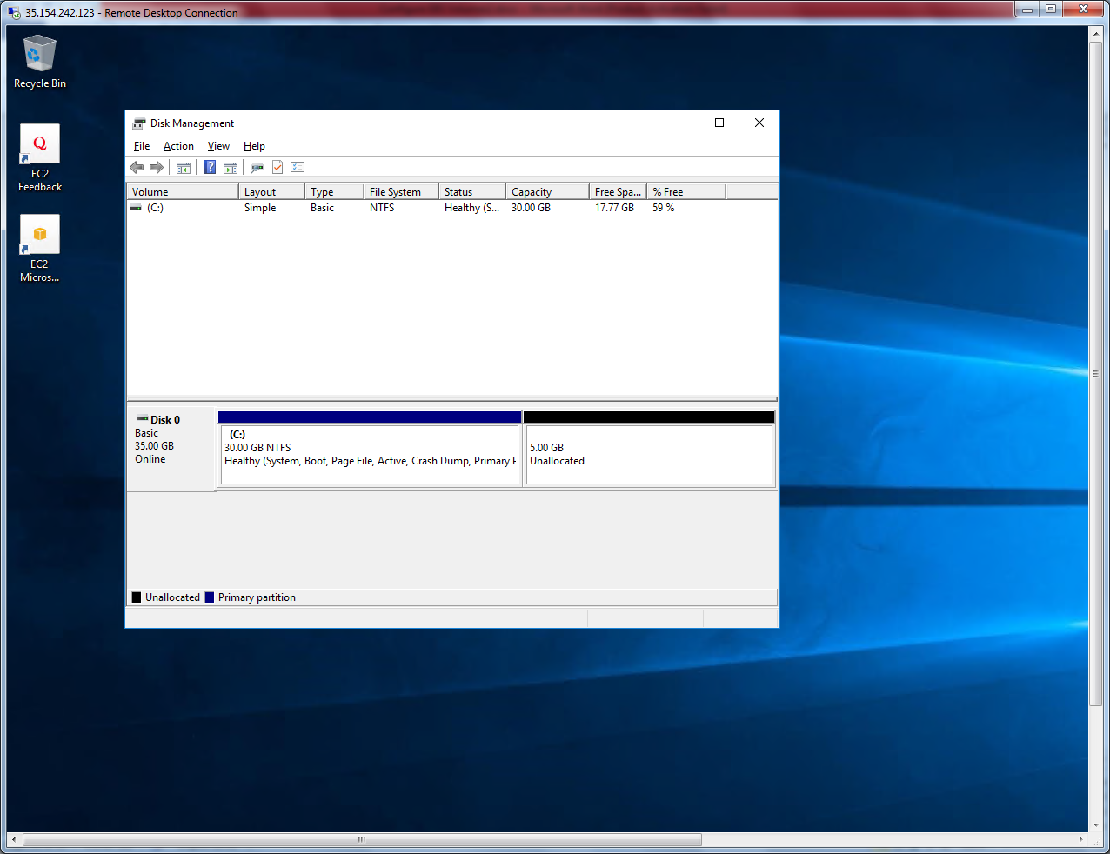

Select the unallocated partition and right click and then click “New Simple Volume”.

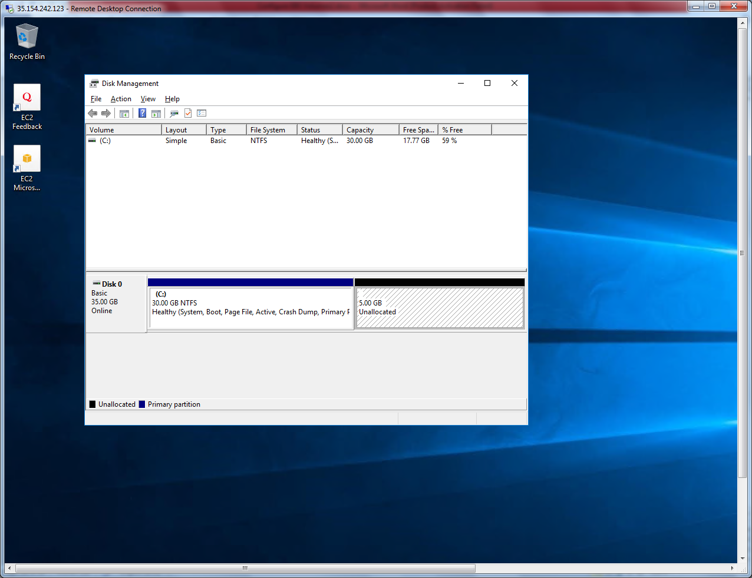

Click “Next”.

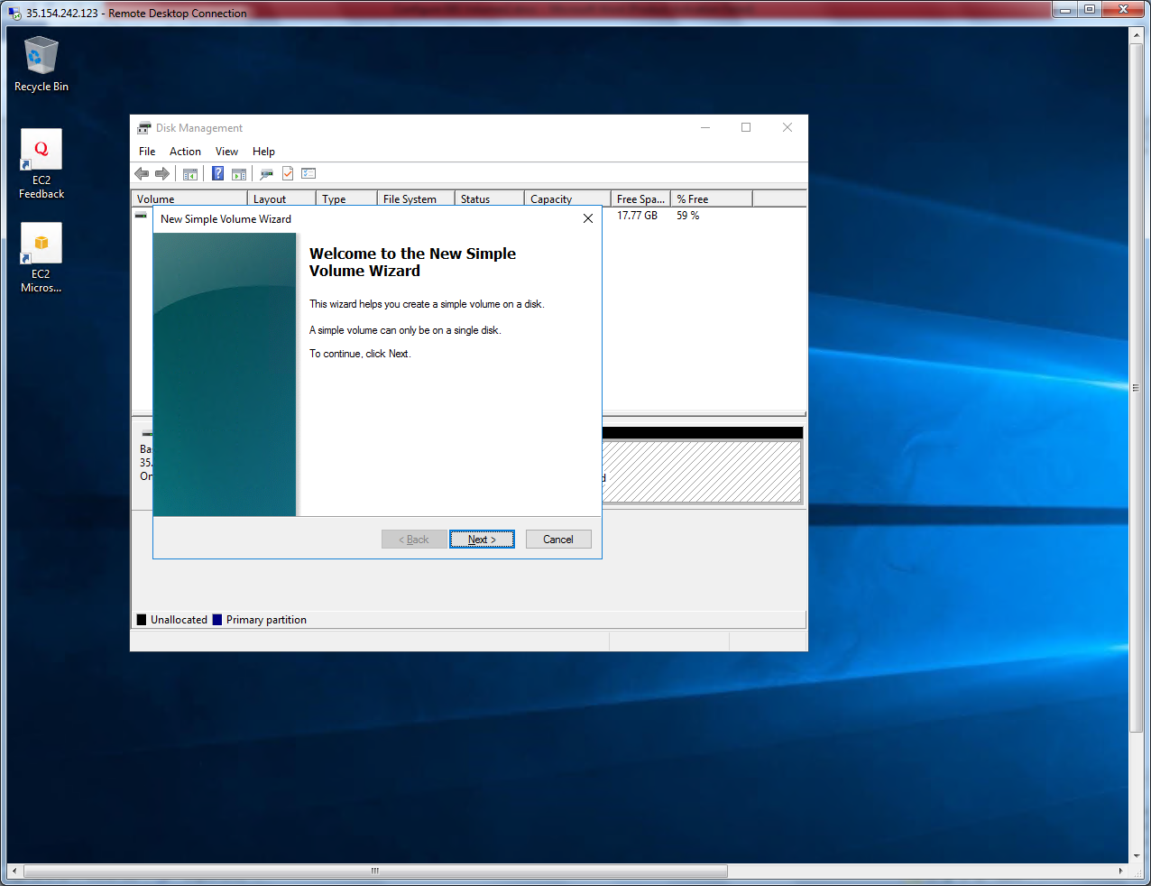

Click “Next”.

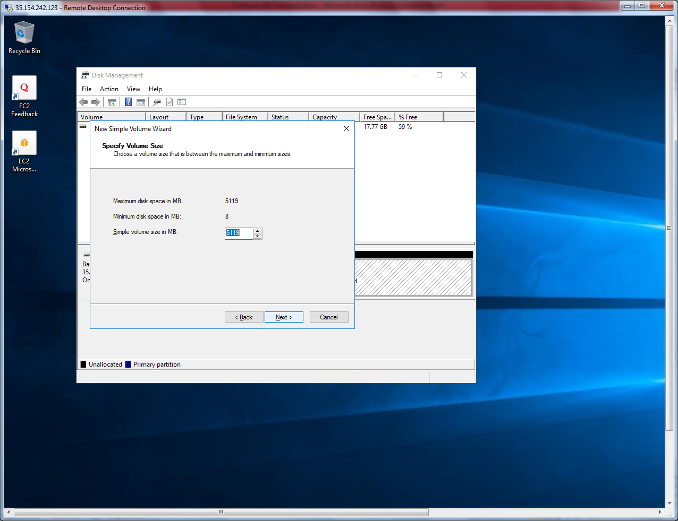

Click “Next”.

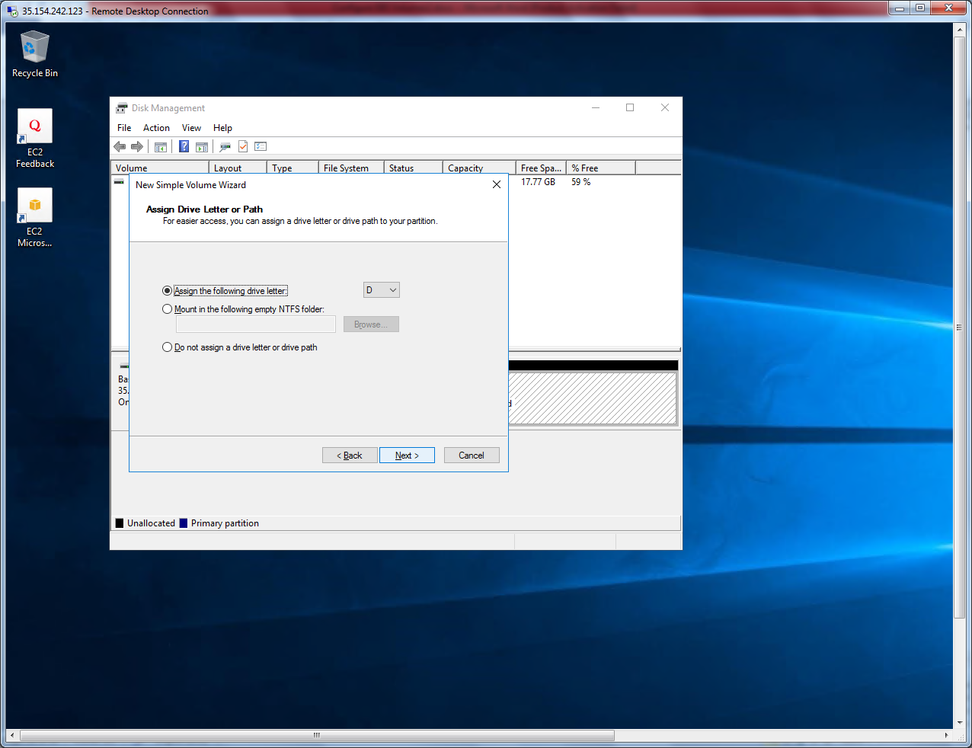

Click “Next”.

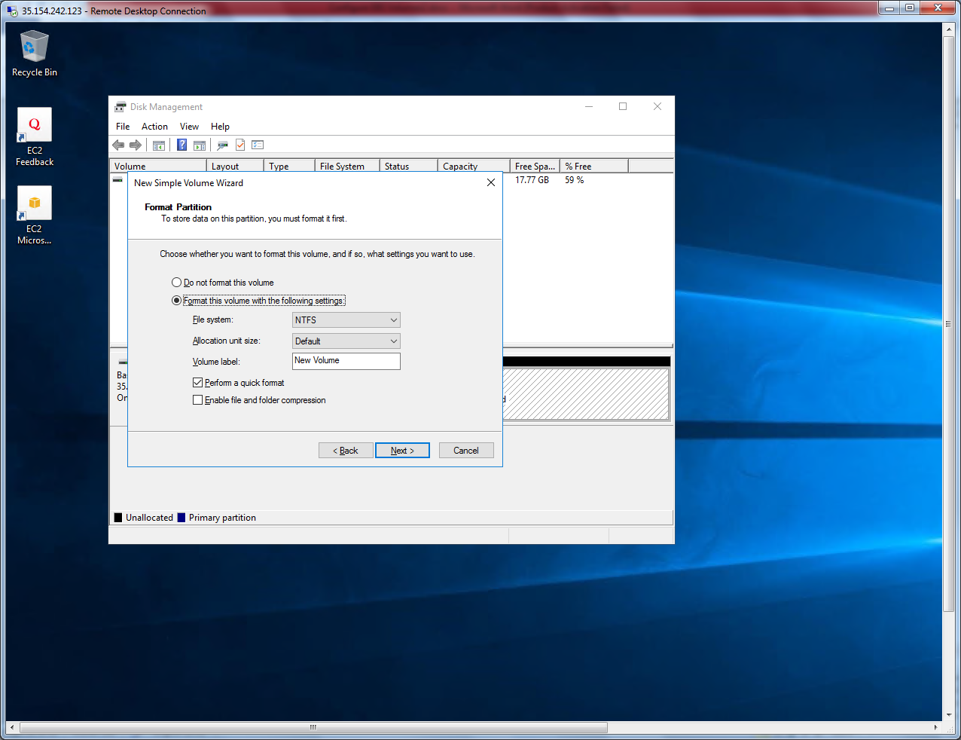

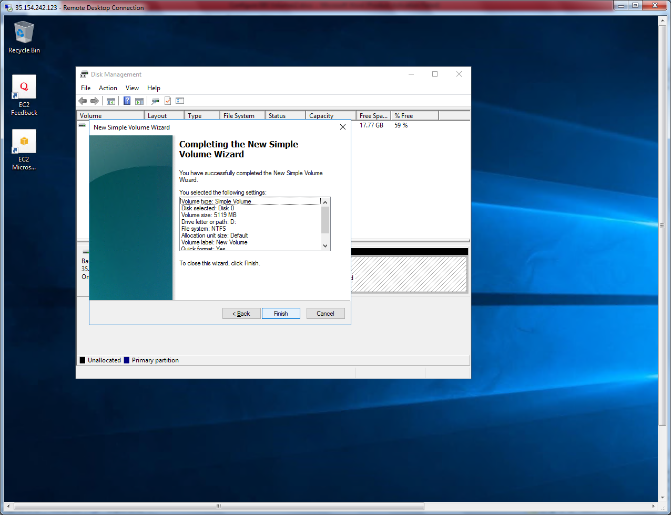

Click ”Finish”.

Now 5GB partition is ready.

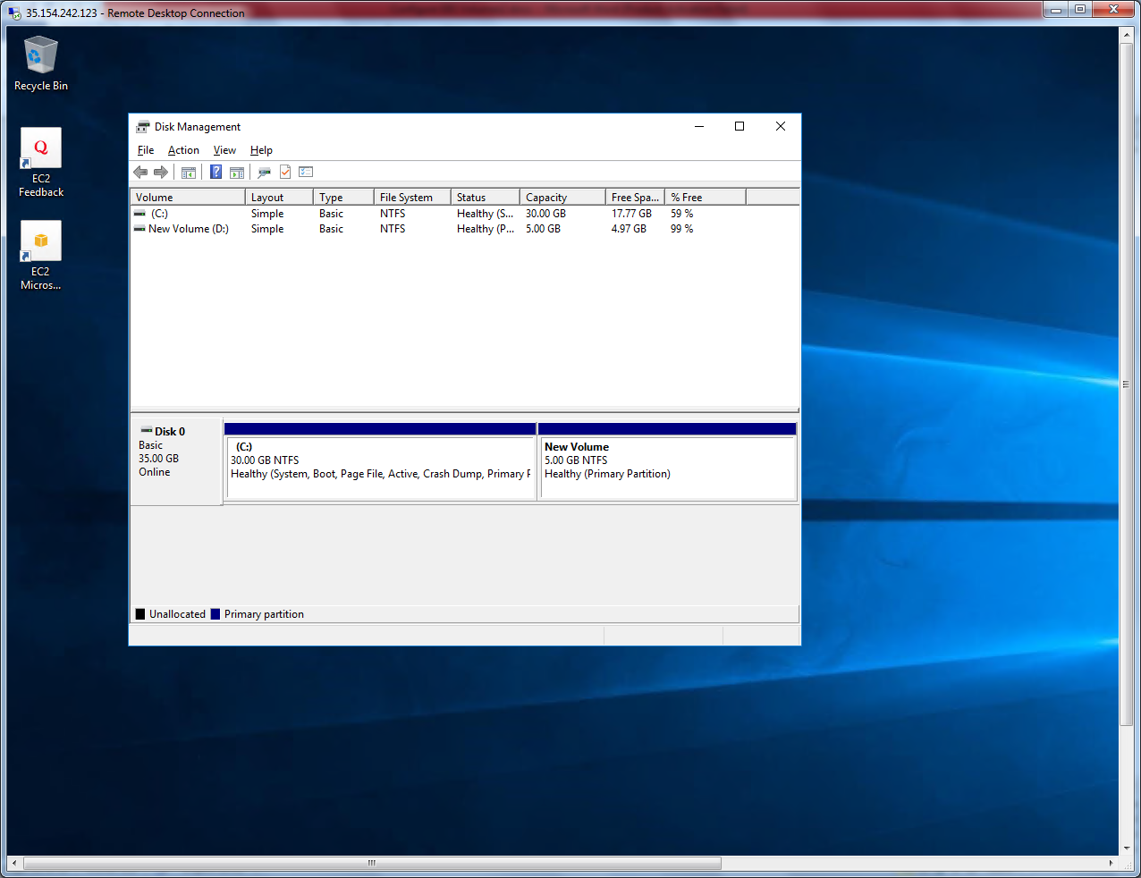

I have stored some data in new volume.

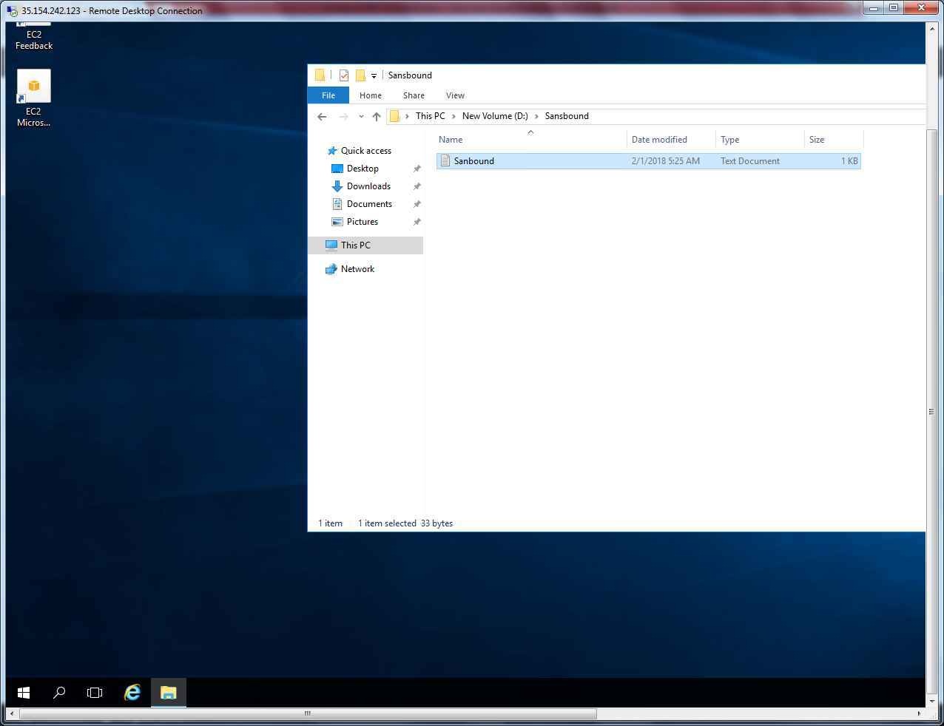

Goto Volume, click “Create Snapshot”.

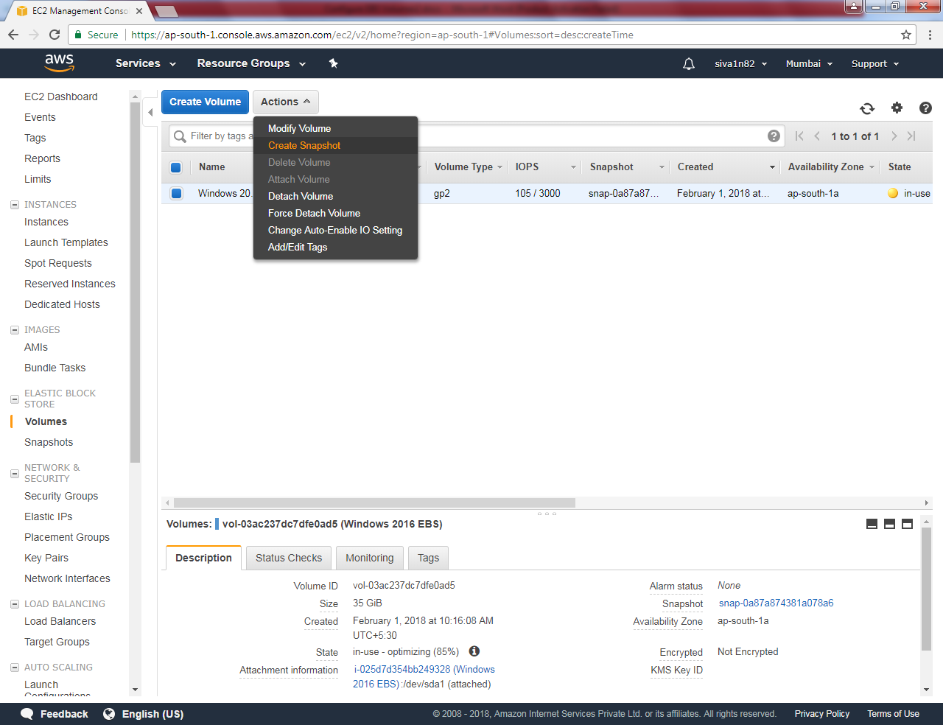

Type Name as “SansboundAMI” and Description as “Sansbound AMI”.

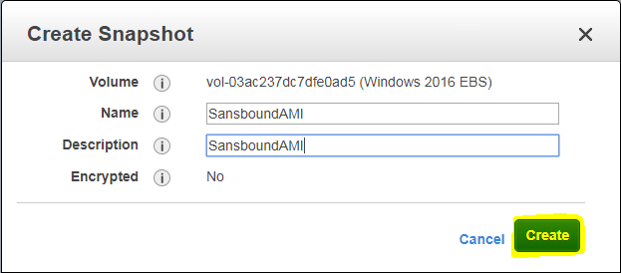

Snapshot creation has been started.

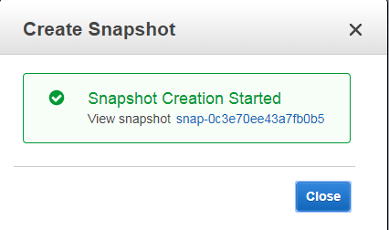

Click snapshot menu,

Now snapshot is completed.

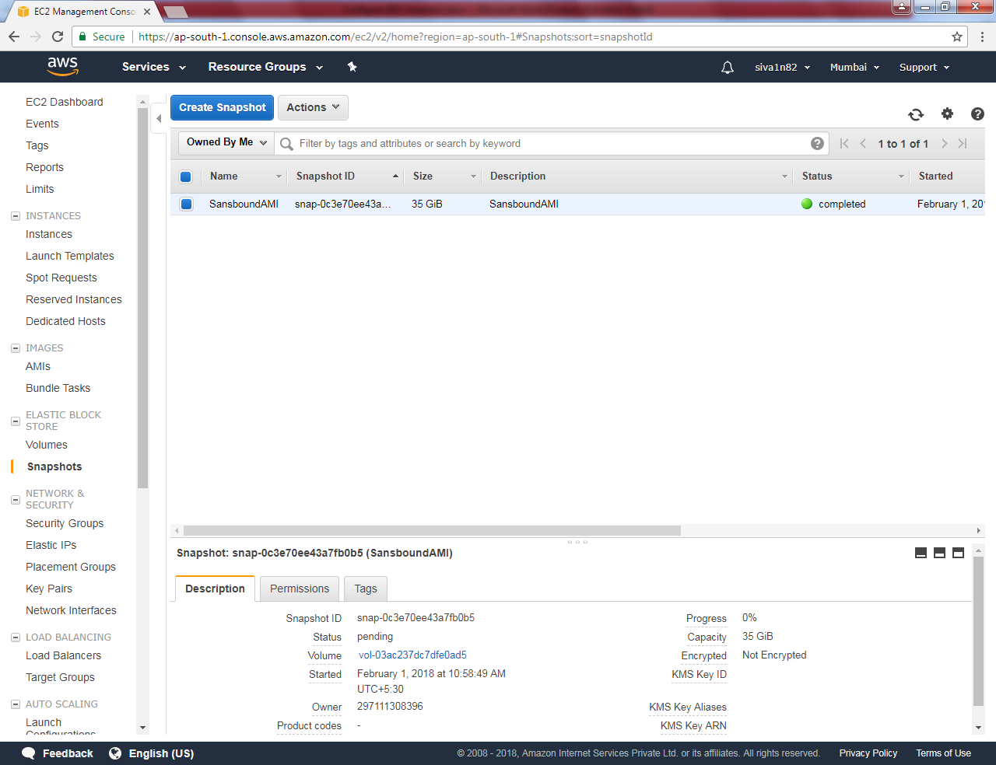

Now we need to create an image by using the snapshot.

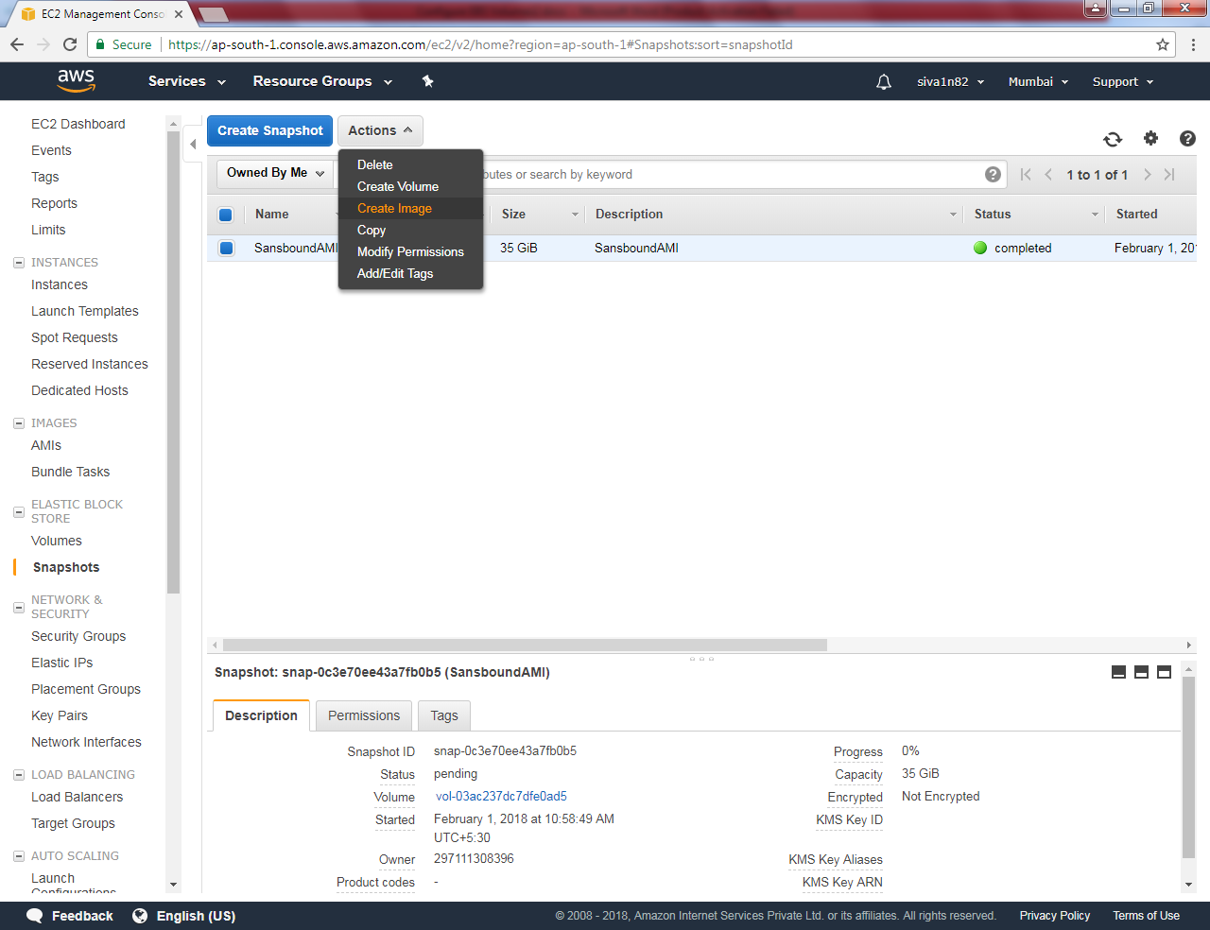

Click “create image”

Type name as SansboundAMI

Description as SansboundAMI

**And Select Hardware-assisted virtualization**

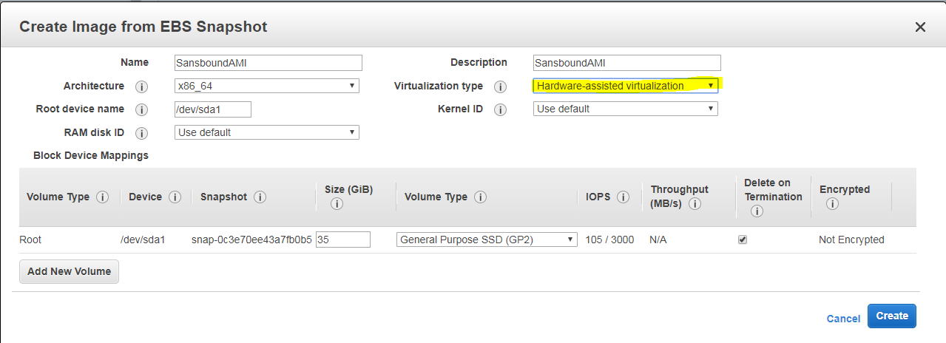

Then click “Create”.

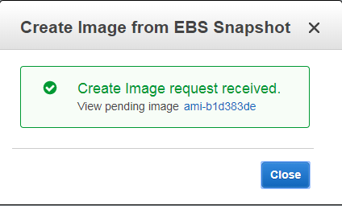

Goto AMIs,

You can able to see that image is available.

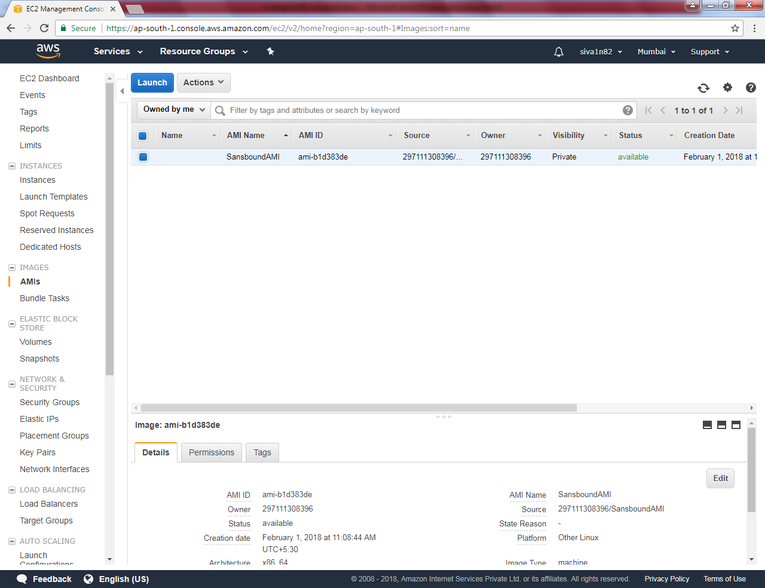

Go to instances, Click “Launch instance”.

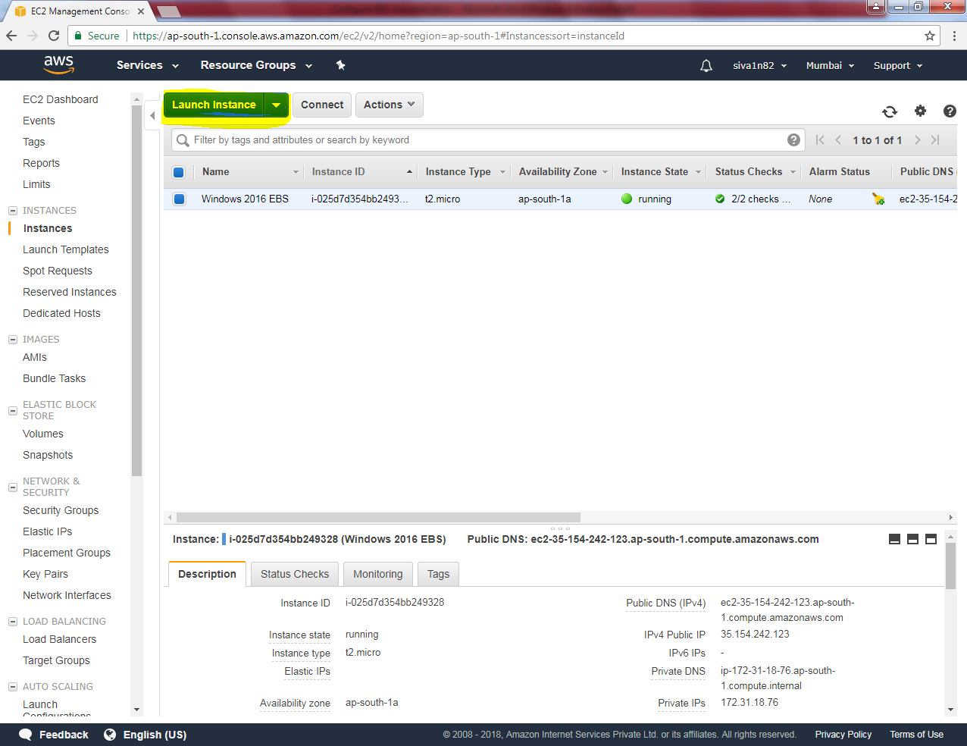

Click “My AMIs” then select Sansbound_AMI.

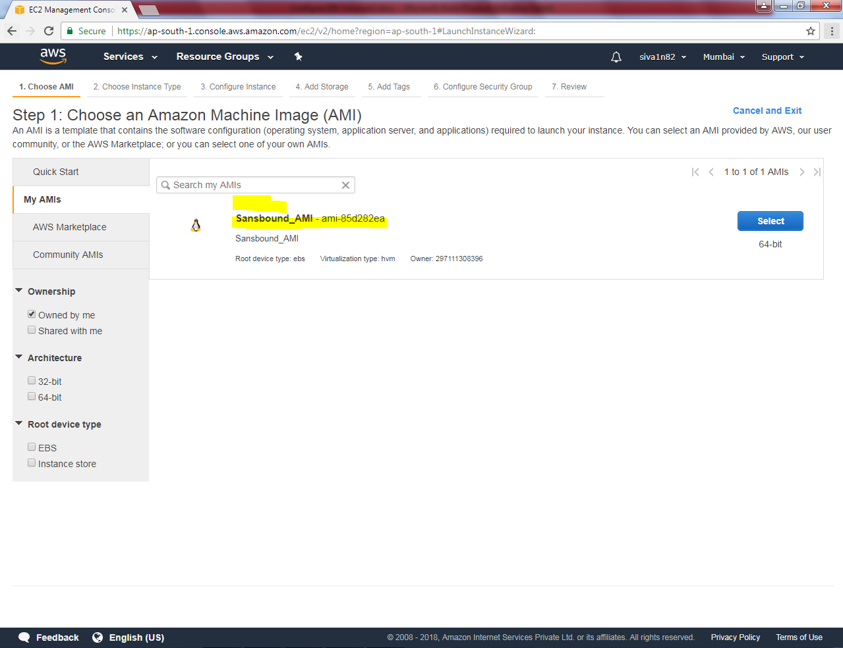

Select “t2.micro”.

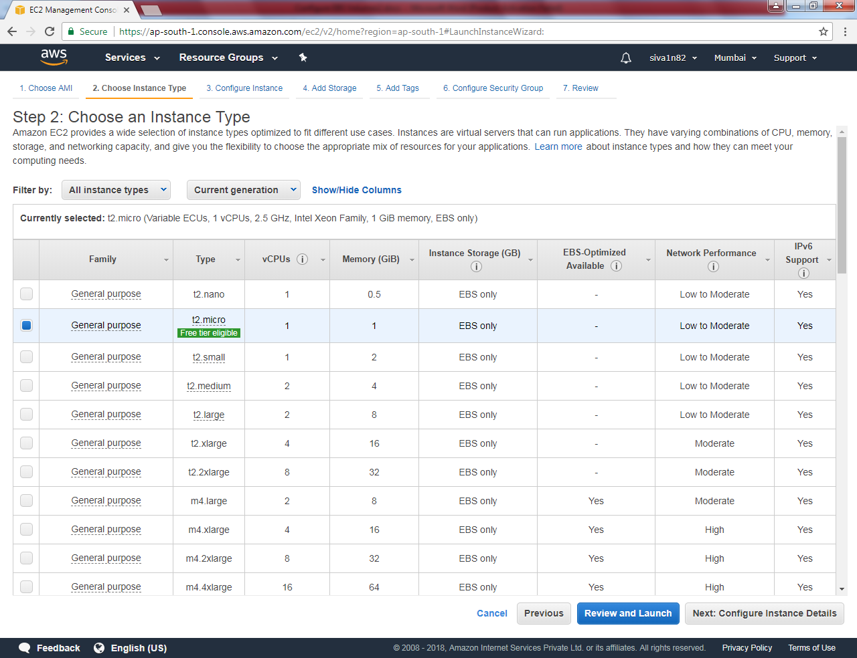

Click “Next”.

Leave default settings and click “Next”.

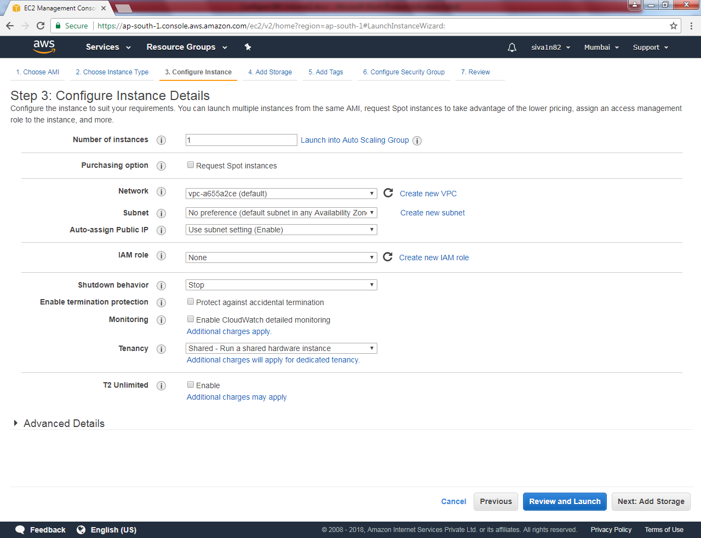

Leave the default settings and click “next”.

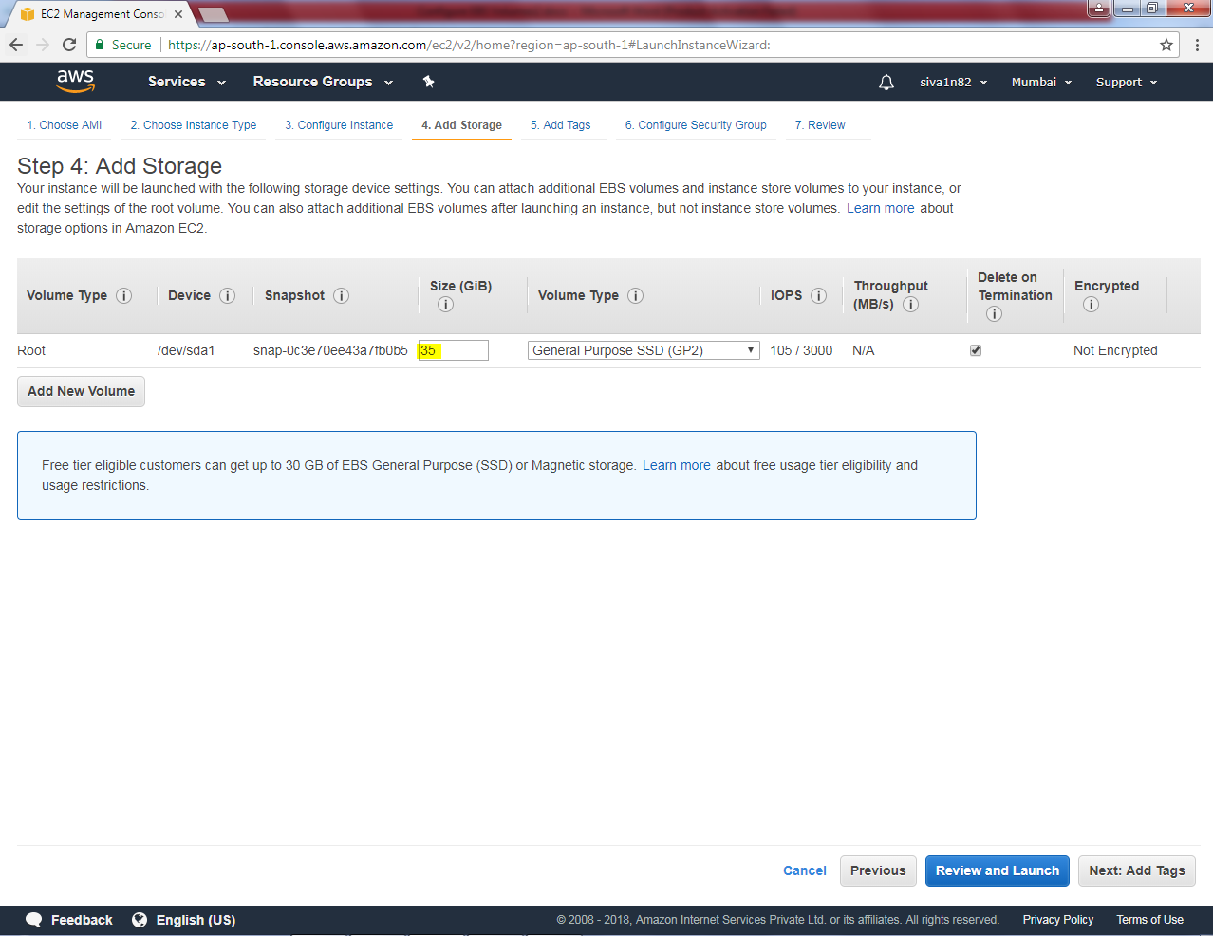

Key as Name and Value s “Windows 2016 AMI”.

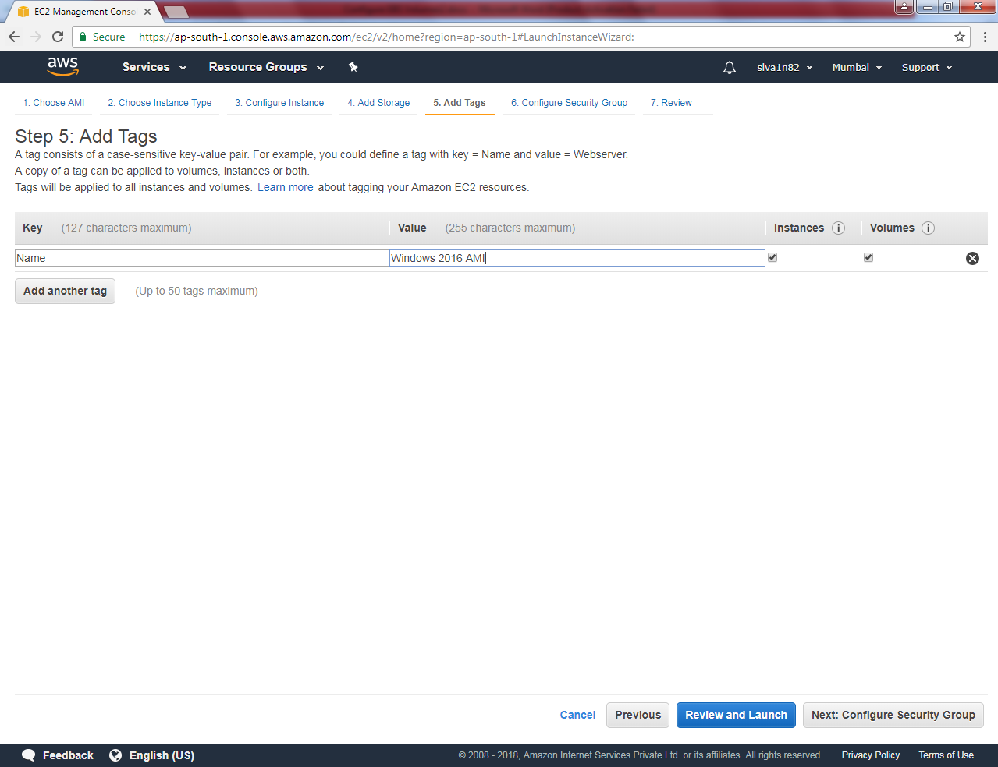

Select using existing group “Mumbai sec Group”.

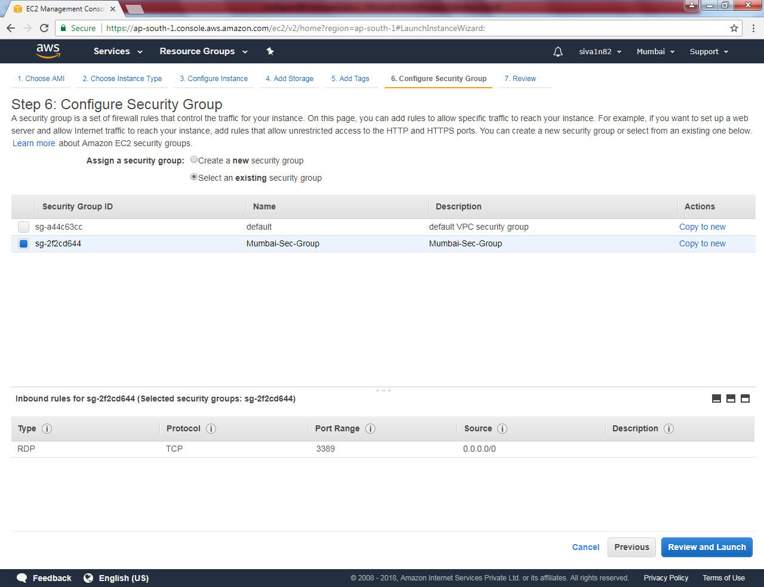

In this stage you will get some message that we need to permit port 22 / ssh to access the system. Please Leave that click “Continue”.

Click ”Launch”.

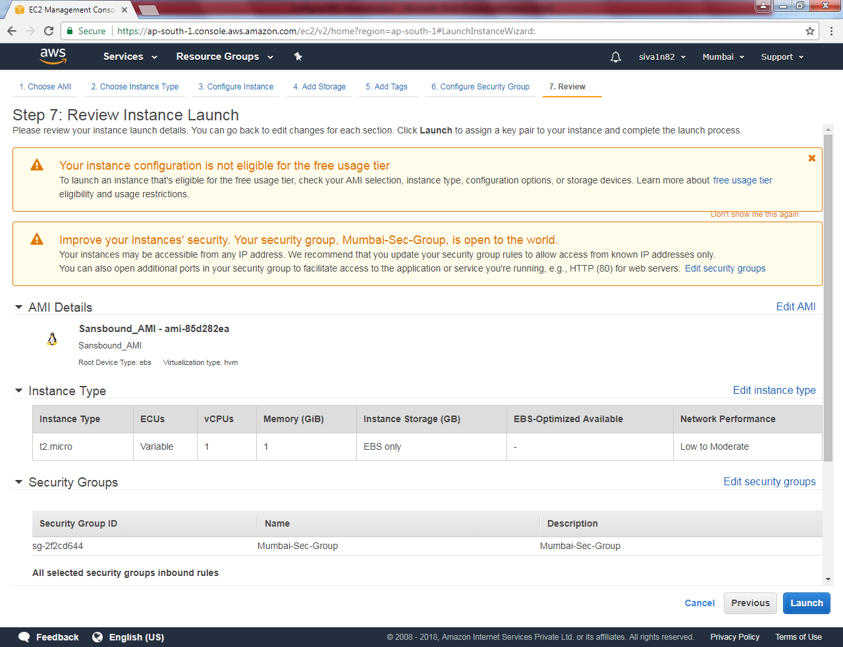

Select the eveningaws key and click “Launch instances”.

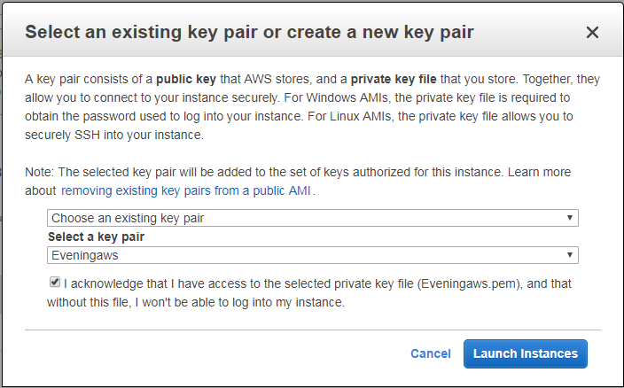

Now the server is ready.

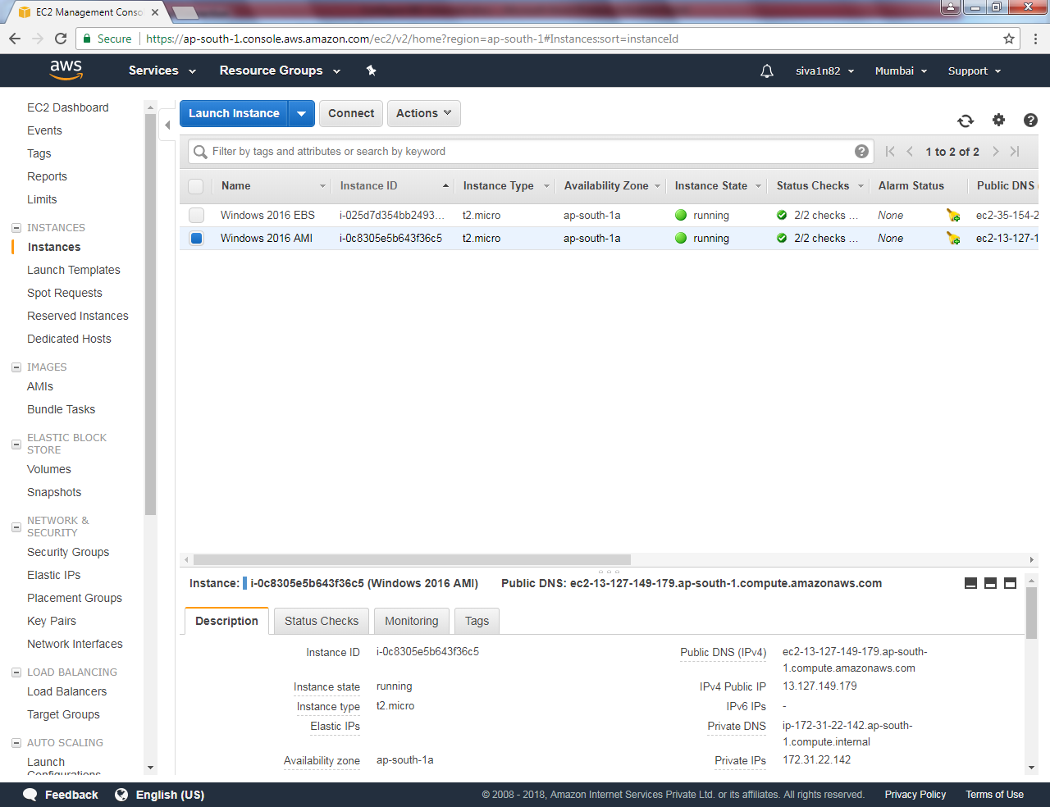

**The output was not come in this scenario. Hence, you need to delete/ terminate the instance.**

Go to snapshots. Select snapshot and then right click. Delete.

Go to AMIs, Then you need to deregister the AMI image, it will shows some error.

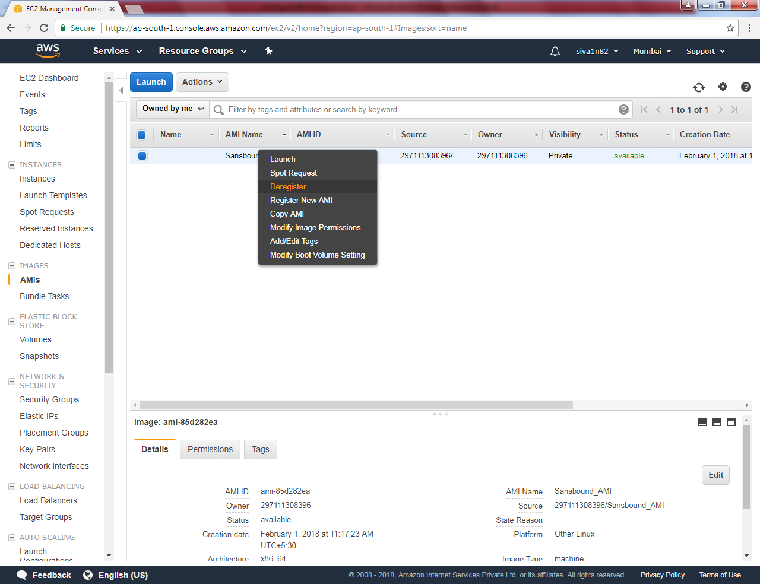

Click “Deregister”.

It will take some time to remove.